**WD-MINOR-PROJECT**

**BY: - ABHAY RAJ**

1. **The project is made by Abhay Raj, Email - abhayraj2002@hotamil.com of August Batch of Web Development Batch.**
2. **The links for the GitHub project are: -** [**GitHub Link**](https://github.com/rajabhay1803/WD-MINOR-AUGUST.git)**.**

**SCREENSHOT OF THE PAGE: -**

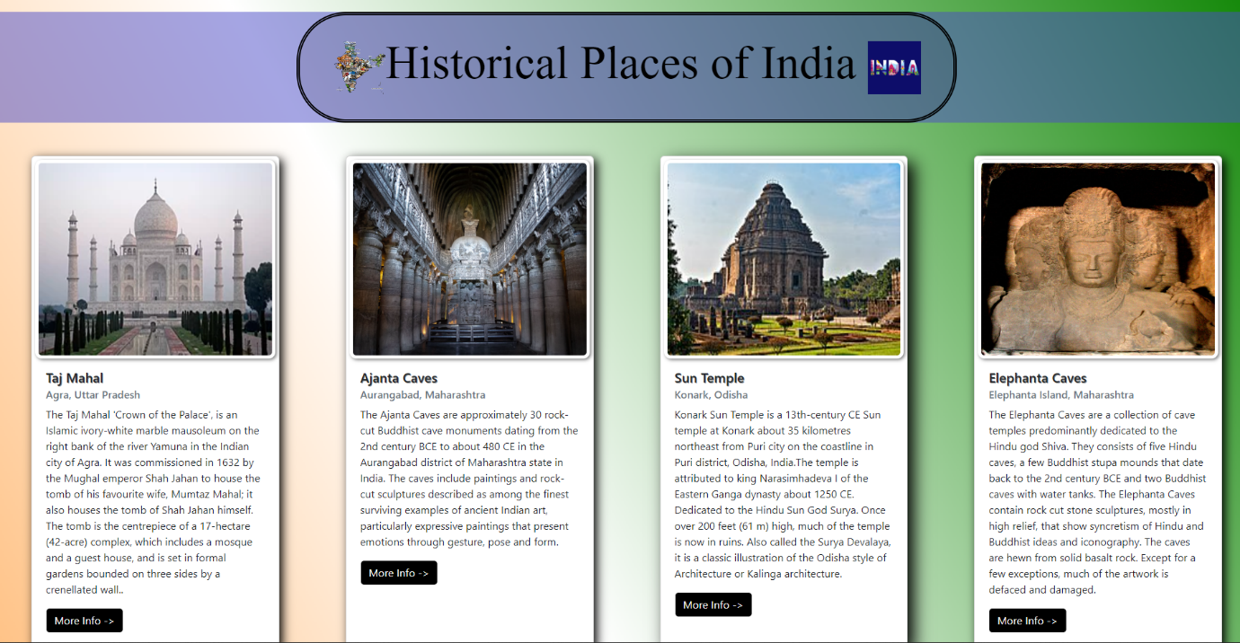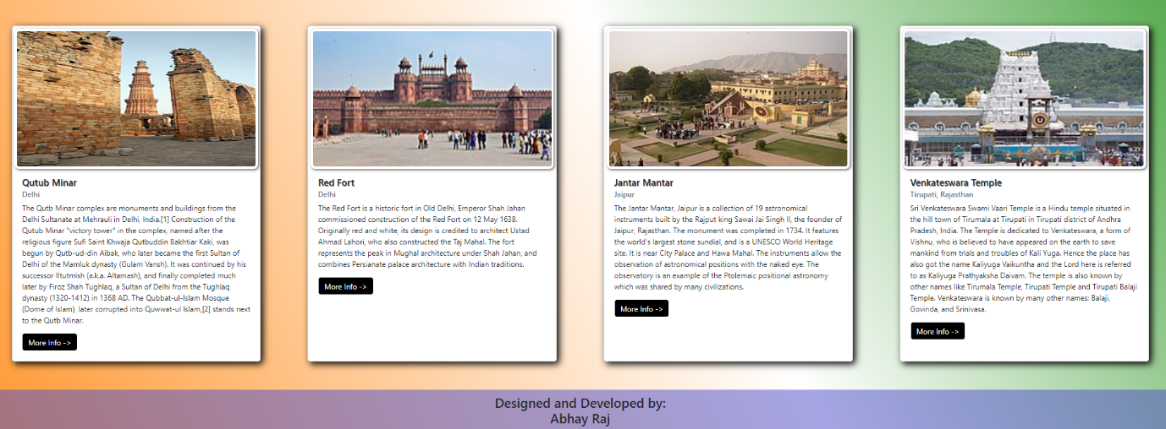

**THE SCREEN SHOT FOR THE PAGE AND CODE USED IN MAKING THE PAGE: -**

1. **THE HEADER OF THE PAGE: -**





1. **MAKING OF THE BODY: -**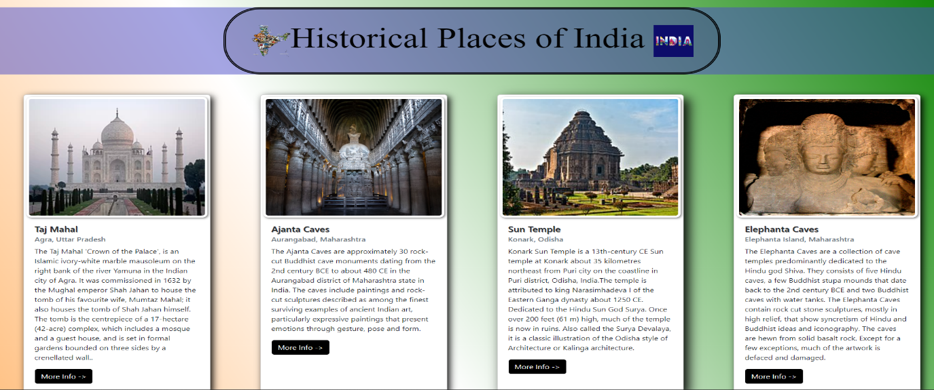

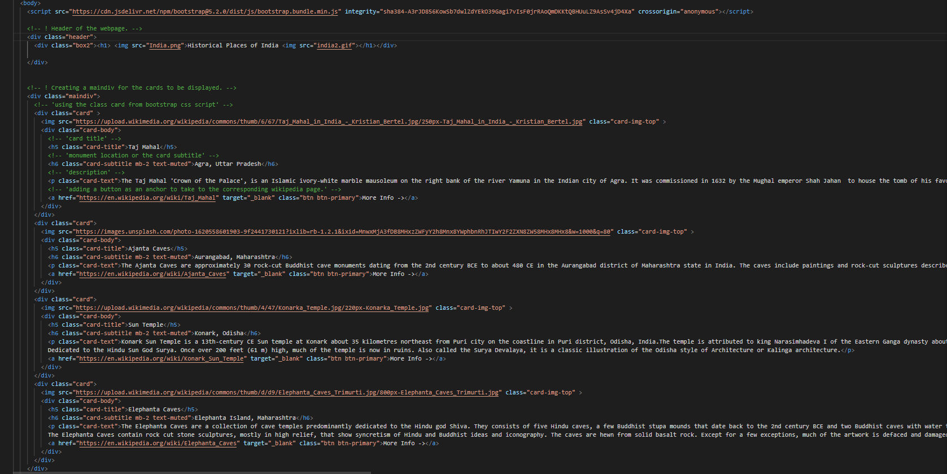

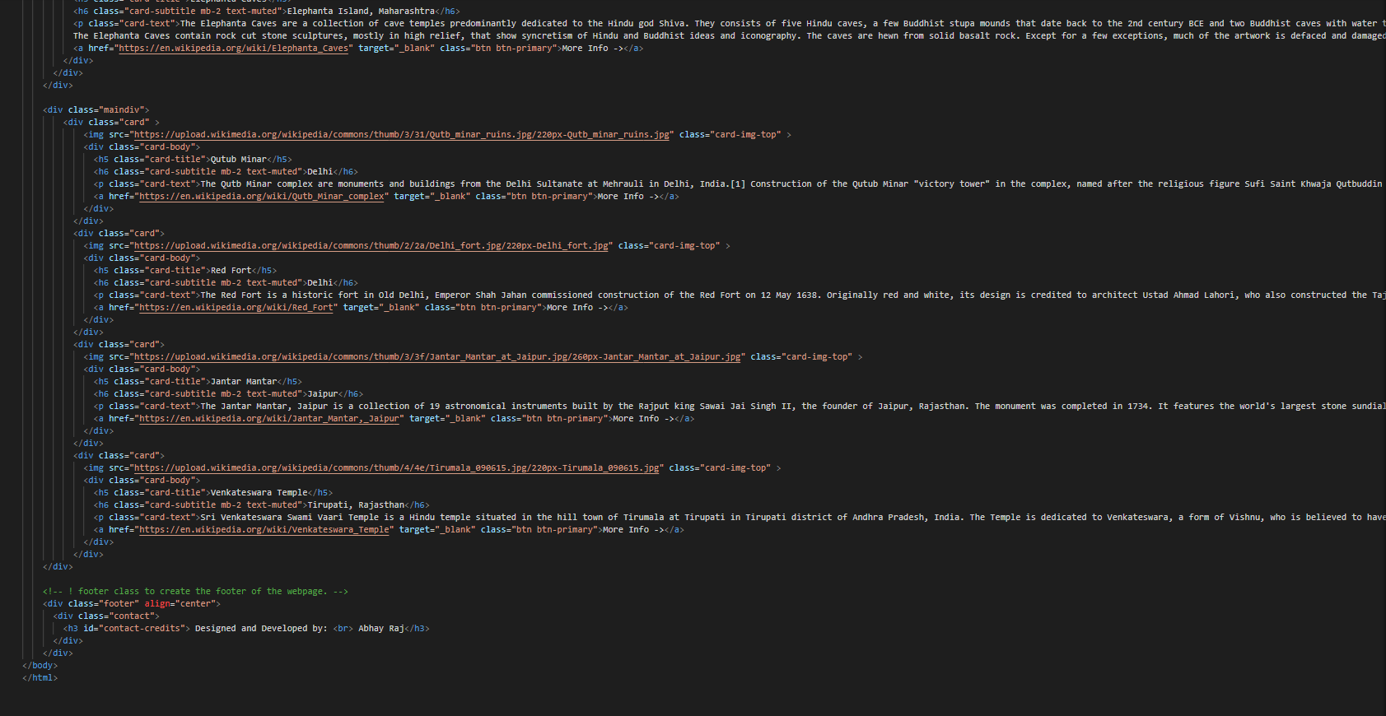

1. **MAKING OF THE TILES: -**

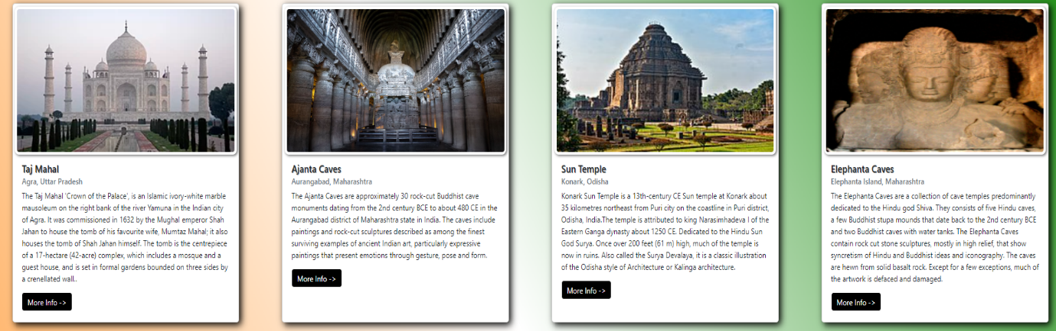

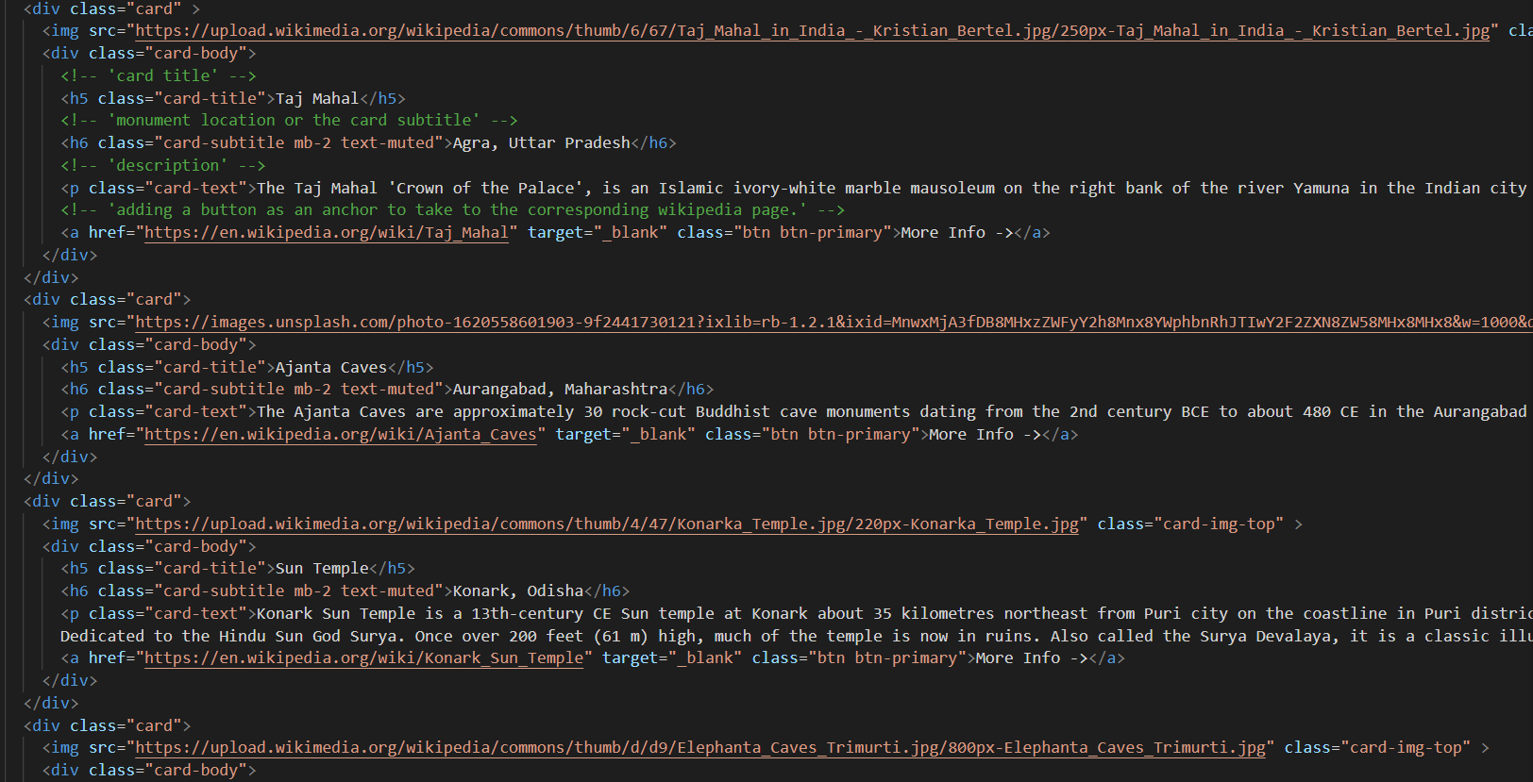

1. **USING HYPERLINKS: -**

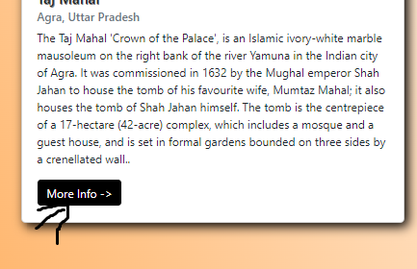



1. **FOOTER OF THE WEBPAGE: -**

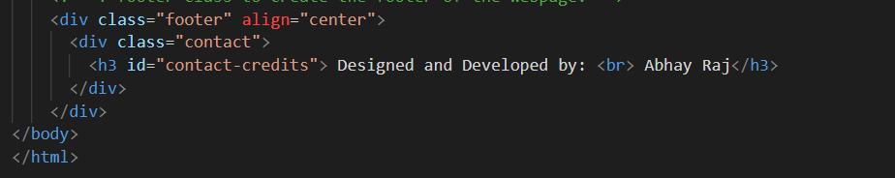

1. **CSS CODE: -**

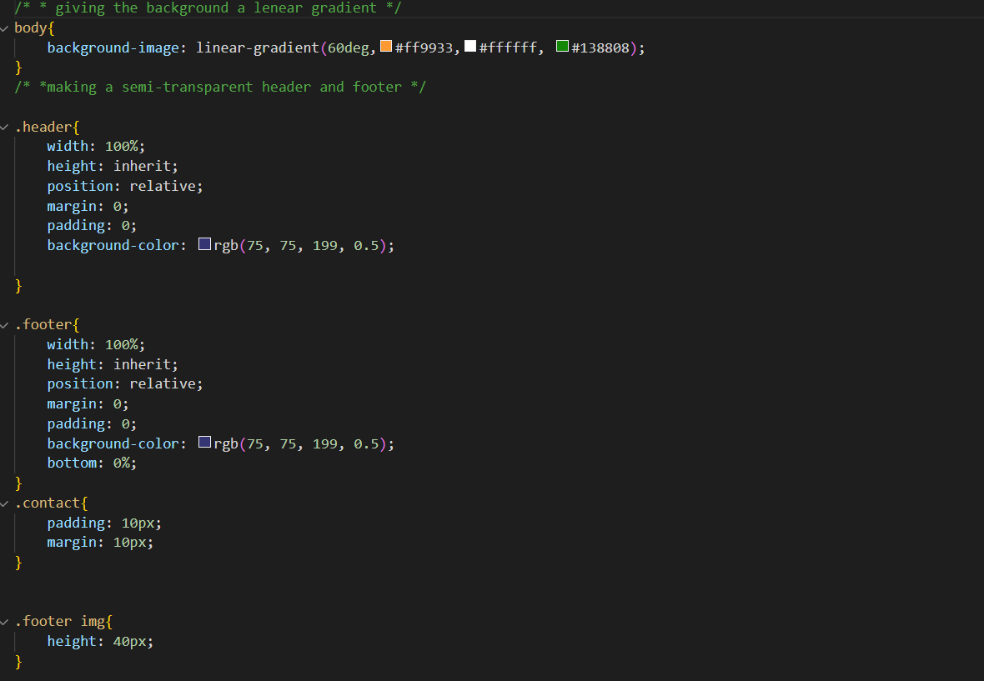

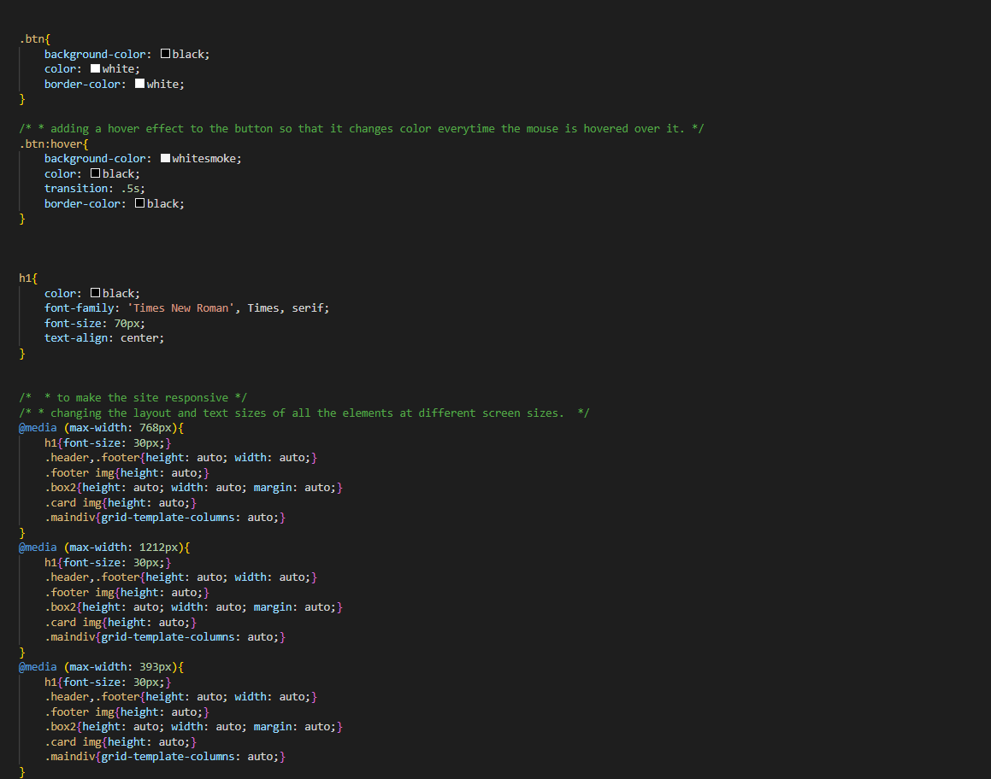

**THANK YOU**

**BY: - ABHAY RAJ**